Environmental Assessment Report for Recovery & Reuse of Asphalt Products [RAP] & Recovered Roading Aggregates [RRA] used by Auckland Aggregates to Produce their RRA Range of Base Coarse Aggregates & Drainage Chip.
Executive Statement:
In response to the growing need in New Zealand for sustainable solutions in infrastructure development, the supplier, Fulton Hogan, embarked on an assessment of recycled asphalt products [RAP], which is the aggregate used to produce Auckland Aggregates recovered roading aggregates [RRA] drainage chip labelled as RRA 18/6 along with RRA [GAP]10, RRA[GAP]20, RRA[GAP]40 & RRA[GAP]65 products.
This report outlines the environmental assessment conducted to evaluate the feasibility of utilising RAP aggregates in various applications, addressing concerns regarding bitumen leaching and environmental impact. By providing insights into the potential benefits and considerations associated with the reuse of RAP & RRA, this statement aims to guide prospective purchasers considering the RRA range of aggregates from Auckland Aggregates.

1. Introduction
Recycled asphalt products [RAP] including all Auckland Aggregates RRA products, derived from end-of-life asphalt pavements, pose opportunities for sustainable reuse. The Environmental Solutions team has conducted an assessment regarding the potential environmental impacts and planning considerations associated with utilising RRA in various applications. This report outlines findings and recommendations.
2. Analytical Testing
2.1 Site Works: A site visit to Fulton Hogan’s, Reliable Way RAP processing plant was conducted to collect representative samples of RAP. Three samples were collected from different parts of the stockpile area to account for potential variation in feedstock. Samples were dispatched to an accredited laboratory for analysis.
2.2 Laboratory Analysis: Samples underwent Synthetic Precipitation Leaching Procedure (SPLP) to assess potential leaching of contaminants, particularly bitumen-related compounds. Leachate analysis revealed no detectable levels of Total Petroleum Hydrocarbons (TPH) or Polycyclic Aromatic Hydrocarbons (PAH), indicating that the bitumen in RAP samples is not leachable under environmental conditions.
3. Discussion
The absence of hydrocarbon detections in the leachate suggests that all Auckland Aggregates RRA products pose minimal environmental risk when used in proposed applications such as subbase under footpaths, driveways & house floors, subbase bulk filling, drainage metal, retaining wall backfill. However, it is advised to avoid using RRA products in aggressive environments or environmentally sensitive locations due to potential negative public perceptions and the difficulty in assessing impacts in such contexts.
4. SQEP Certification
The initial report undertaken has been produced and reviewed by Suitably Qualified and Experienced Practitioners (SQEP) in Contaminated Land.
David Duncan, Fulton Hogan Environmental Solutions Project Manager has over 11 years of experience in contaminated land consultancy and remediation in New Zealand and the United Kingdom. He is a chartered member of the Chartered Institution of Water and Environmental Management (CIWEM) and a Chartered Scientist (UK Science Council). He is a member of the Waste Minimisation Institute of New Zealand (WasteMINZ), the Australasian Land and Groundwater Association (ALGA), and the Society of Brownfield Risk Assessment (SOBRA).
Tim Dee, Fulton Hogan National Environmental Solutions Manager has worked for over 15 years as a consultant and contractor across Australasia, Europe, and the Middle East delivering the remediation and assessment of contaminated land. Tim is a Chartered Chemist and the current chair of the WasteMINZ Contaminated Land Management Sector Group. Tim holds an MSc in Chemistry which focussed on the biogeochemistry of the Waikato River.

Conclusion:
Based on the environmental assessment conducted, RAP sourced from Fulton Hogan and designated RRA by Auckland Aggregates, is a viable resource for reuse in specified engineering applications. Its utilisation will contribute to resource recovery initiatives & reduction in environmental footprint by users such as Auckland Aggregates, provided it is employed in suitable contexts and in alignment with environmental best practices. Further, the absence of detectable contaminants concludes that regulatory approvals or resource consents are not required for its use, pending local regulations.

E&OE

Product Images:
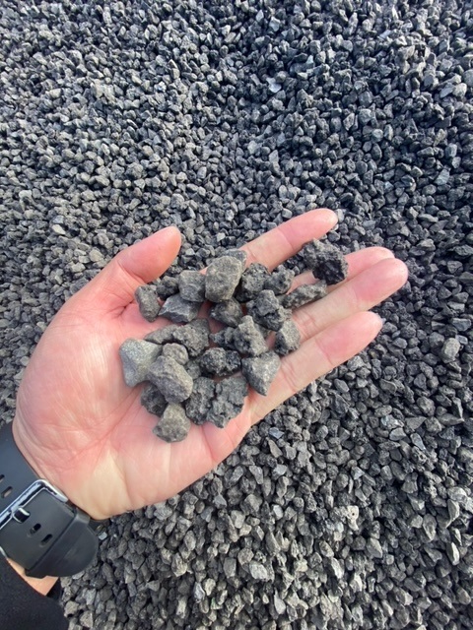
RAP based metal processed by Auckland Aggregates as an RRA product

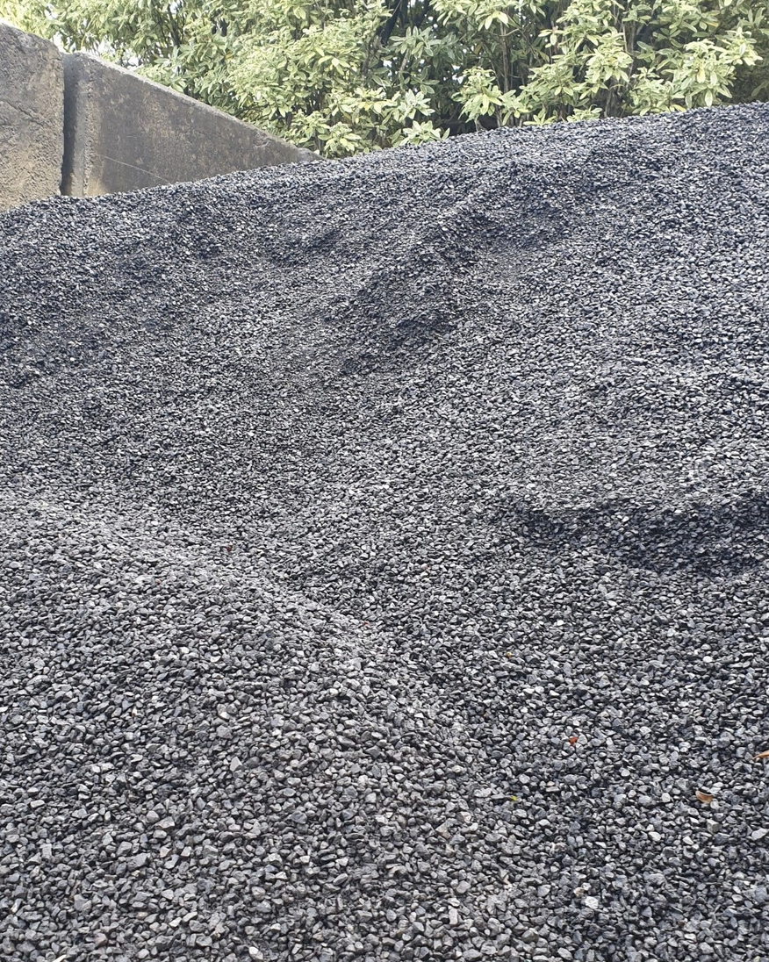

Auckland Aggregates RRA18/6 Drainage metal

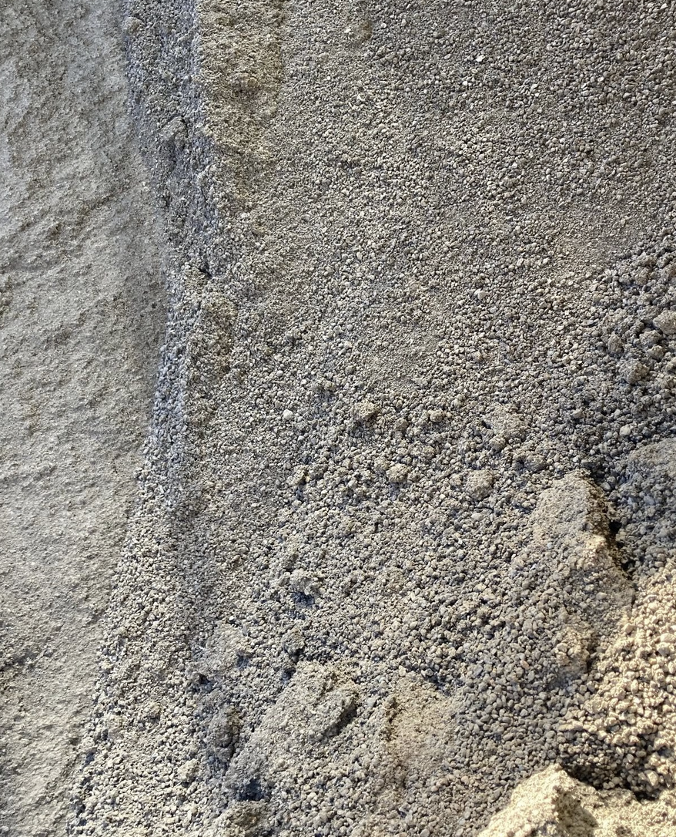
Auckland Aggregates RRA GAP10

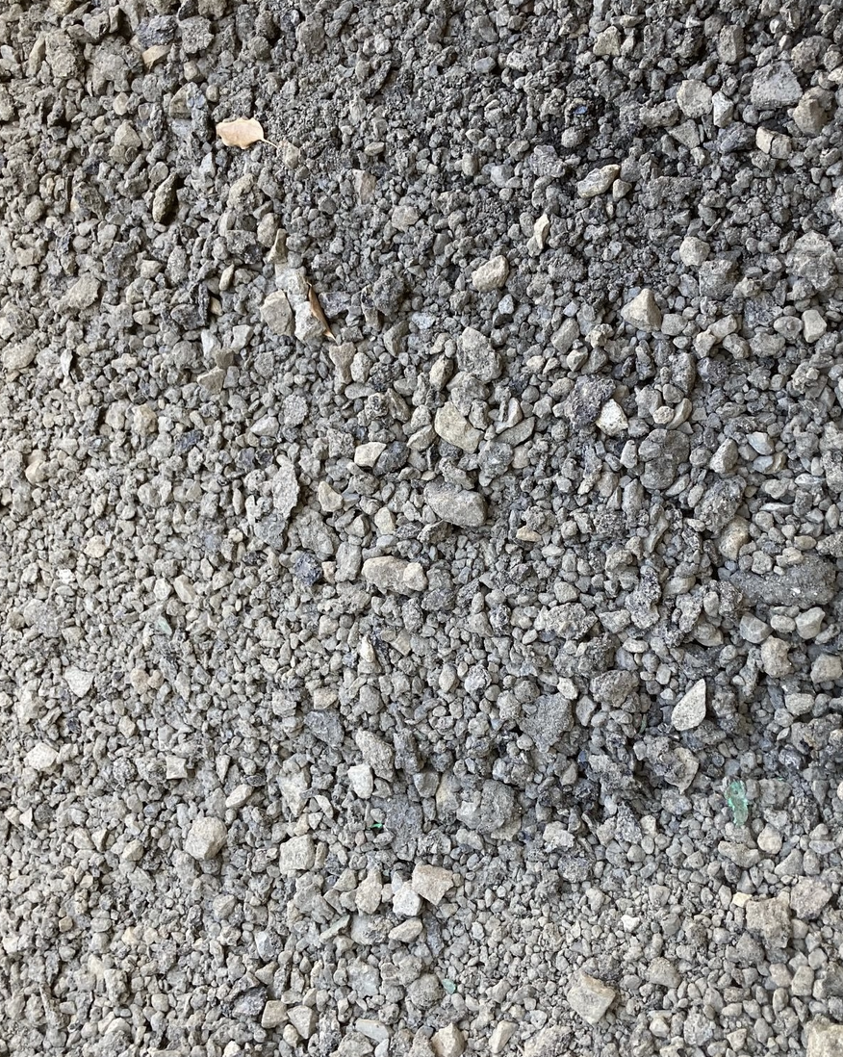
Auckland Aggregates RRA GAP20

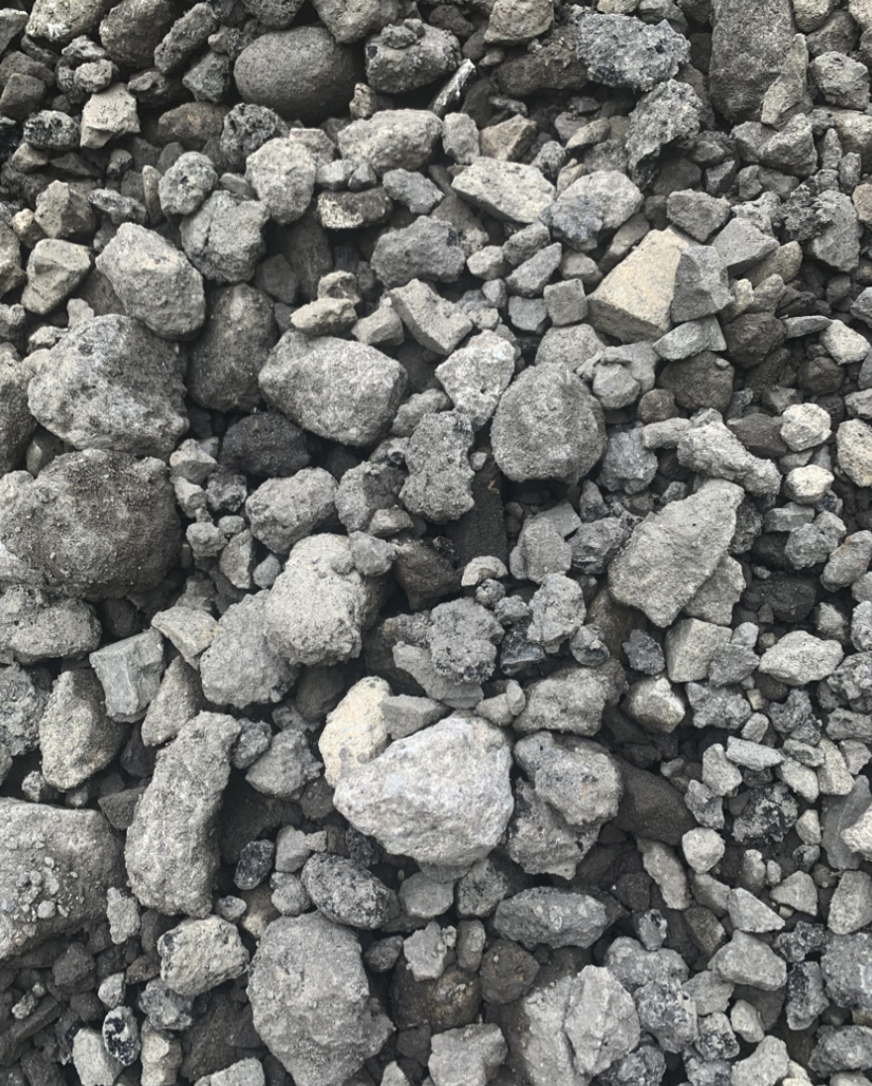
Auckland Aggregates RRA GAP40

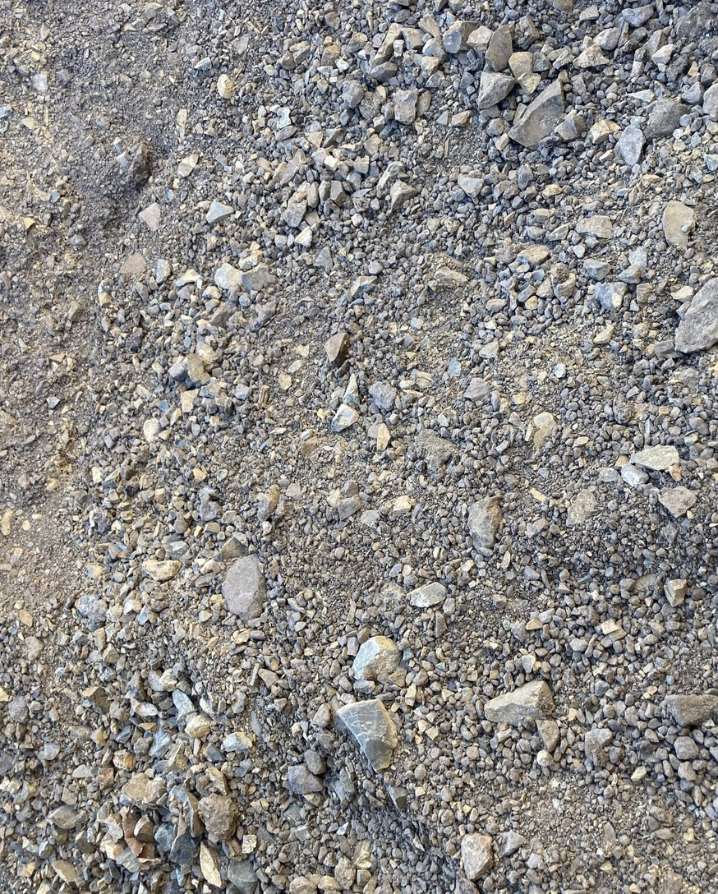

Auckland Aggregates RRA GAP65

For more information CLICK HERE or Phone 0272652932

END:

